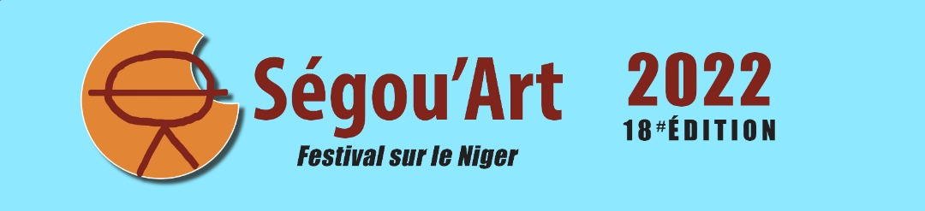

CONTEMPORARY ART FAIR OF MALI
FEBRUARY 01-06, 2022

REGISTRATION FORM FOR SEGOU' ART OFF
(Complete and send before December 20, 2021)

NAME AND SURNAME OF THE APPLICANT: ……………………………………………………………………………………………………………………..

PHONE NUMBER :………………..……………………………………………………………………………..

E-MAIL ADDRESS :………………………………………………………………………………………………

EXHIBITION VENUE IN SEGOU : ………………………………………….………………………………………………………………………….

ADDRESS OF THE EXHIBITION VENUE : ……………………………………………….…………………………………………………………………..

PERIOD OF THE EXHIBITION :..………………………………………………………………………………

DATE AND TIME OF THE OPENING AND OR FINISHING (or "without opening") ……………………………………………………………………………………………………………………..

OPENING AND CLOSING HOURS :…………………………………………………………………………

CLOSING DAYS :………….. …………………………………………………………………………………..

SUMMARY PROJECT FORM

(Complete and send before December 20, 2021)

NATURE OF THE PROJECT :…………………………………………………………………………………

PRESENTATION DU PROJECT (5-10 LINES) :

PARTICIPATING ARTISTS :

No | Name | Surname | Contacts
1
2
3
4
5

Note: Beyond five artists, not all of their names can be included in the program and the event will be presented as a "group exhibition".
I have read the call for submissions and I accept the terms and conditions of registration and participation in the OFF of Ségou' Art / Festival Sur le Niger 2022 (Check the box)
*
This Form, together with the Letter of Intent to Bid can be sent by e-mail to the following addresses: segouart@gmail.com no later than 20 December 2021.

Organizing Committee of Ségou’ Art OFF
BP : 39 Ségou - Mali
Tel. : (+223) 21 32 28 90 / 76 07 29 57
Email : segouart@gmail.com

